
NIKITA THAKUR

SOPHOMORE

7021815065

111thakurnikita111@gmail.com

SKILLS

Soft Skills

Problem solving

Multi-tasking

Leadership

Communication

Organizational

Technical Skills

Python

C++

Numpy & Pandas

Problem solving

Figma

Canva

Scikit learn

Basics of Machine Learning

EDUCATION

HIGHER SECONDARY SCHOOL

ST. WILFRED SCHOOL

2019 - 2021

SECONDARY SCHOOL

RYAN INTERNATIONAL SCHOOL

PROFILE
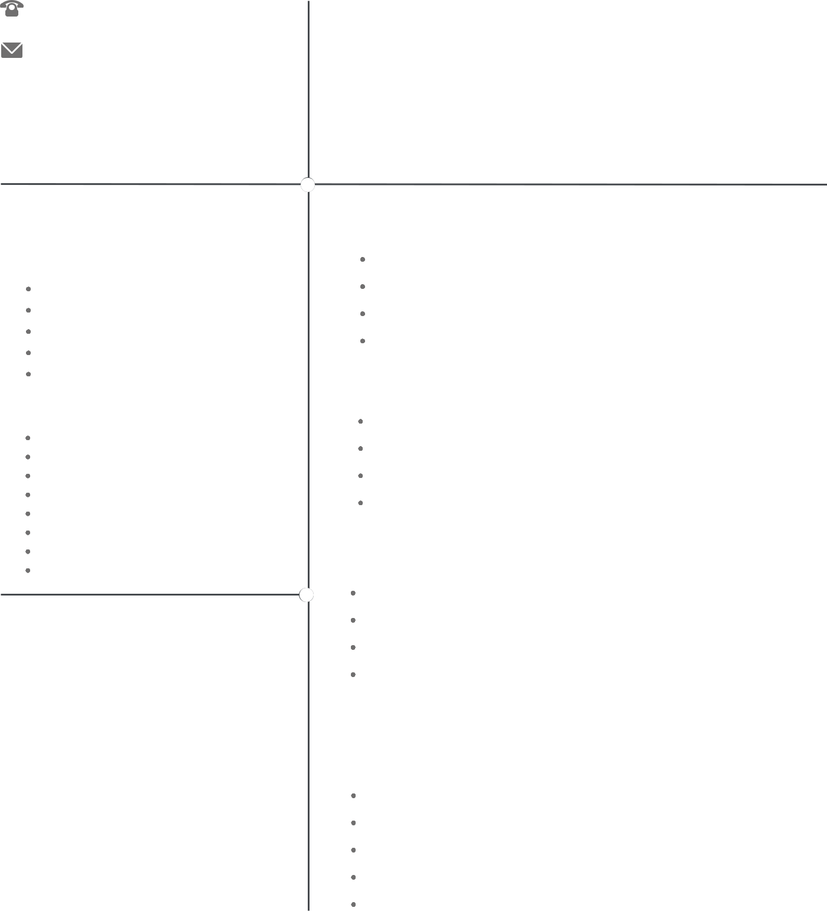

AI enthusiast, and am currently exploring ML and graphic designing.

Good with Python and C++ and have developed few projects in it.

Strong creative and analytical skills. Team player with an eye for detail.

Have good Leadership as well as Communication skills.

ONGOING COURSES

SUPERVISED LEARNING COURSE BY ANDRERW NG (COURSERA)

ACMEGRADE INTERNSHIP PROGRAM IN AI (COMPLETED)

NPTEL - INTRODUCTION TO MACHINE LEARNING (IIT KGP)

NPTEL - ARTIFICIAL INTELLIGENCE (IITM)

PROJECTS

NUMBER GUESSING GAME (PYTHON)

REPOSITORY OF PANDAS

TOWER OF HANOI (PYTHON)

USERNAME AND PASSWORD GENERATOR (C++)

EXPERIENCE

DESIGN COORDINATOR AT GDSC DYPCOE DESIGN COORDINATOR AT ISA(DYPCOE)

VOLUNTEERED TECHNICAL EVENT (SAMBHAV) ON BEHALF OF ISA VOLUNTEERED AT GOOGLE CYBERSECURITY ROADSHOW EVENT

GRAPHIC DESIGNING

PROJECTS

MANAGING UI/UX OF GDSC DYPCOE WEBSITE

LOGO FOR DAZZLE BOUTIQUE

BANNERS FOR DAZZLE BOUTIQUE

LOGO FOR INSTAGRAM PAGE

GAMING LOGO FOR YOUTUBE CHANNEL

